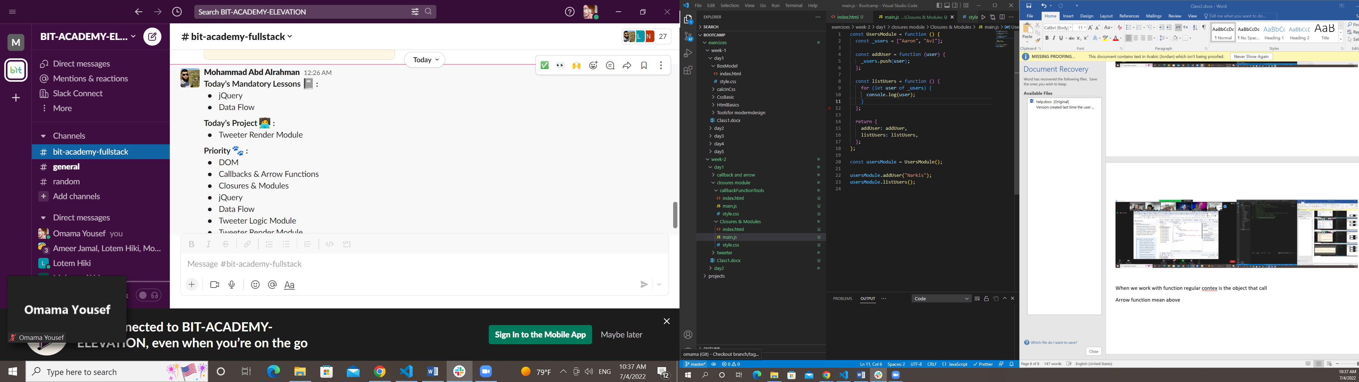

Event propagation

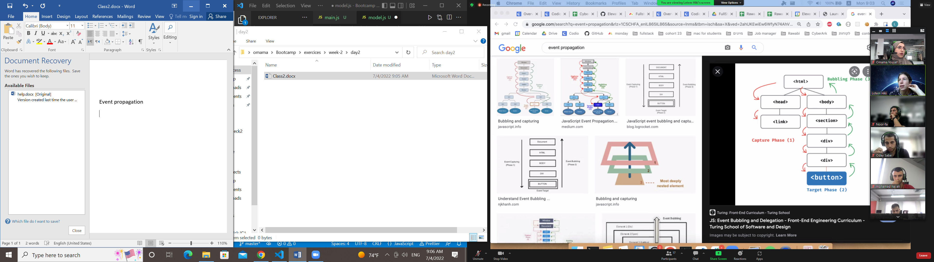

Callback functions

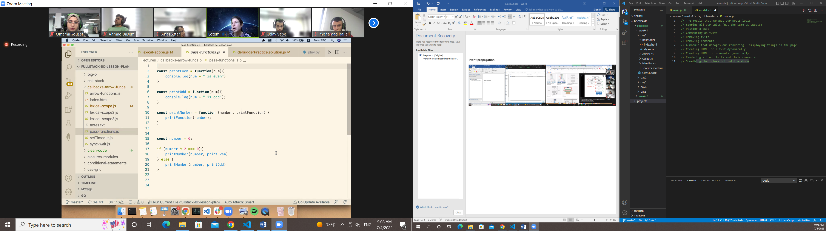

Code stat the execution

Then backtracking

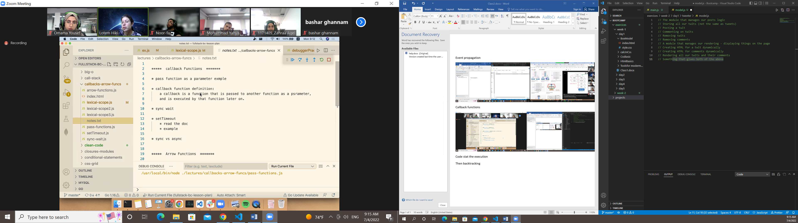

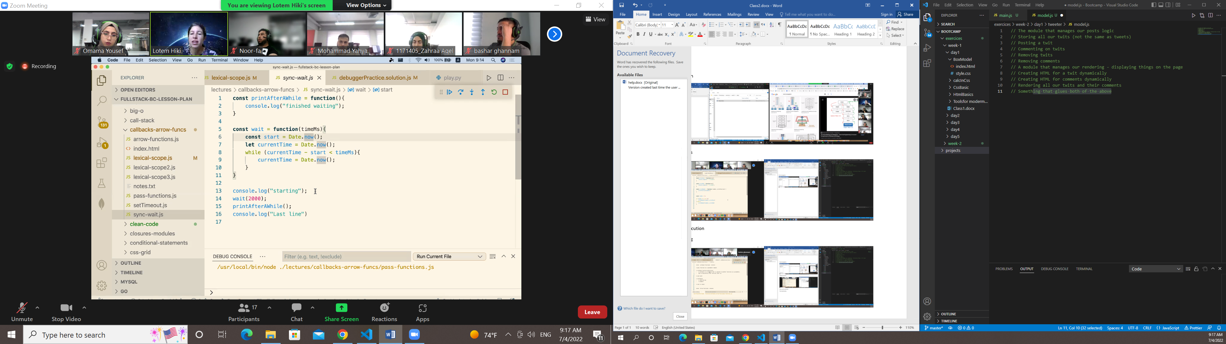

Delay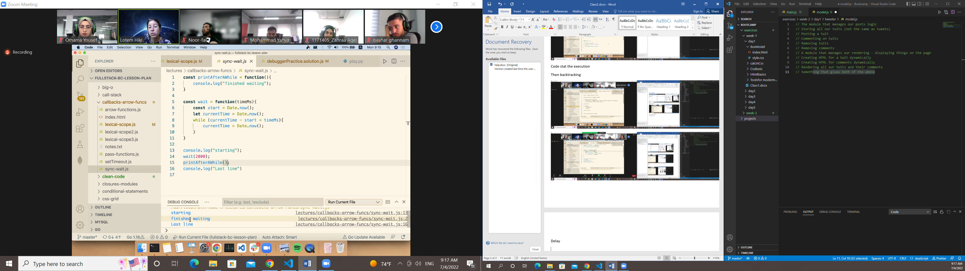

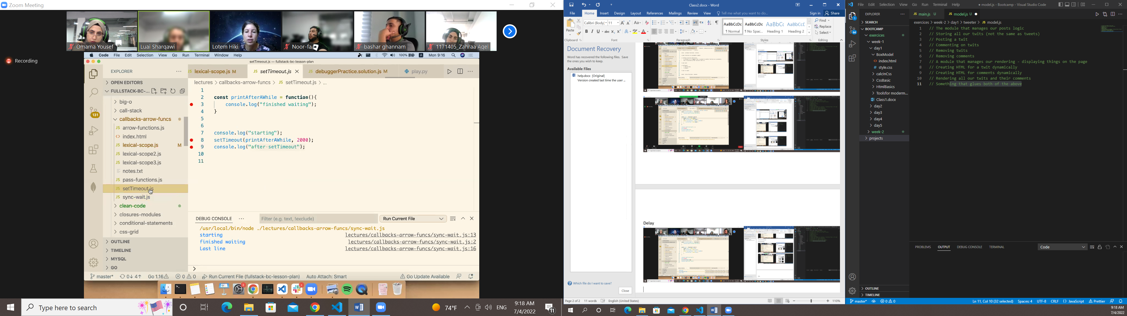

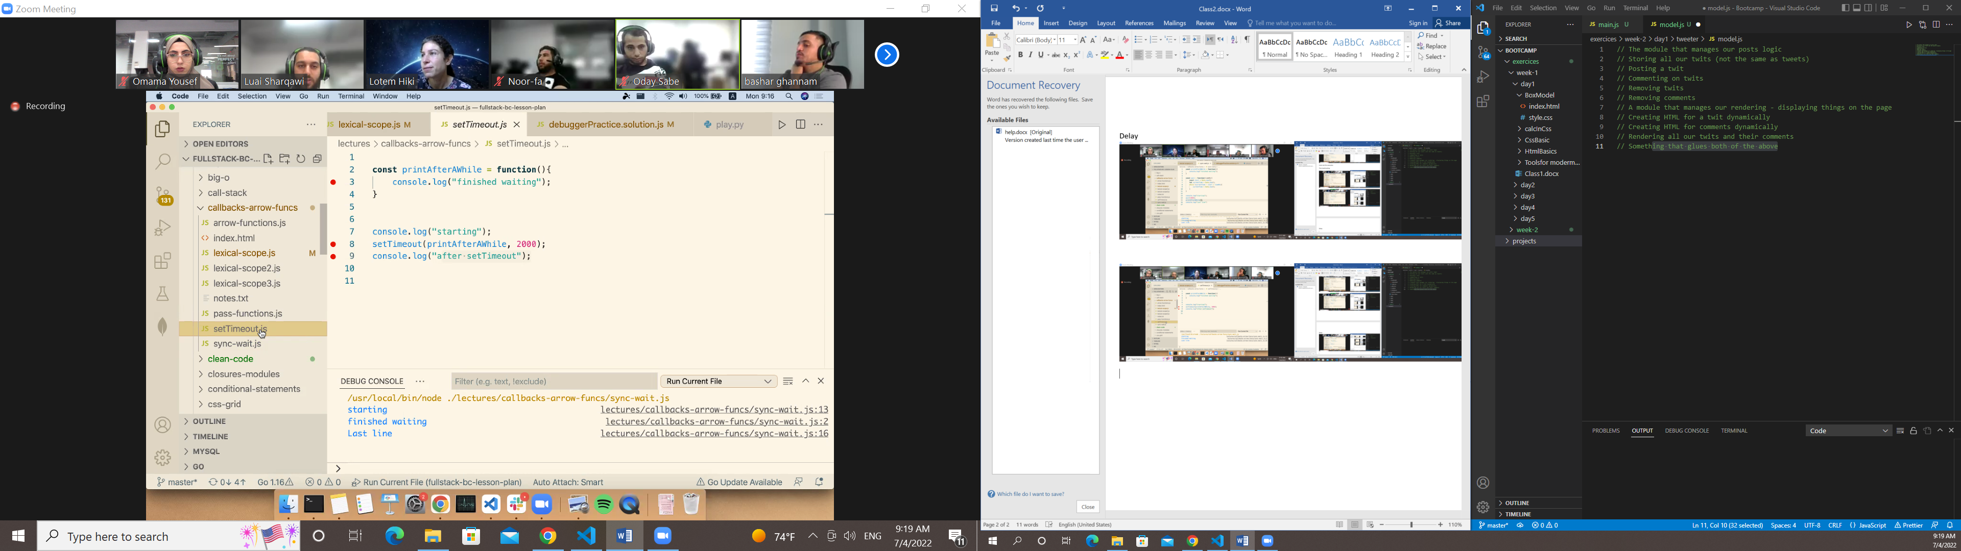

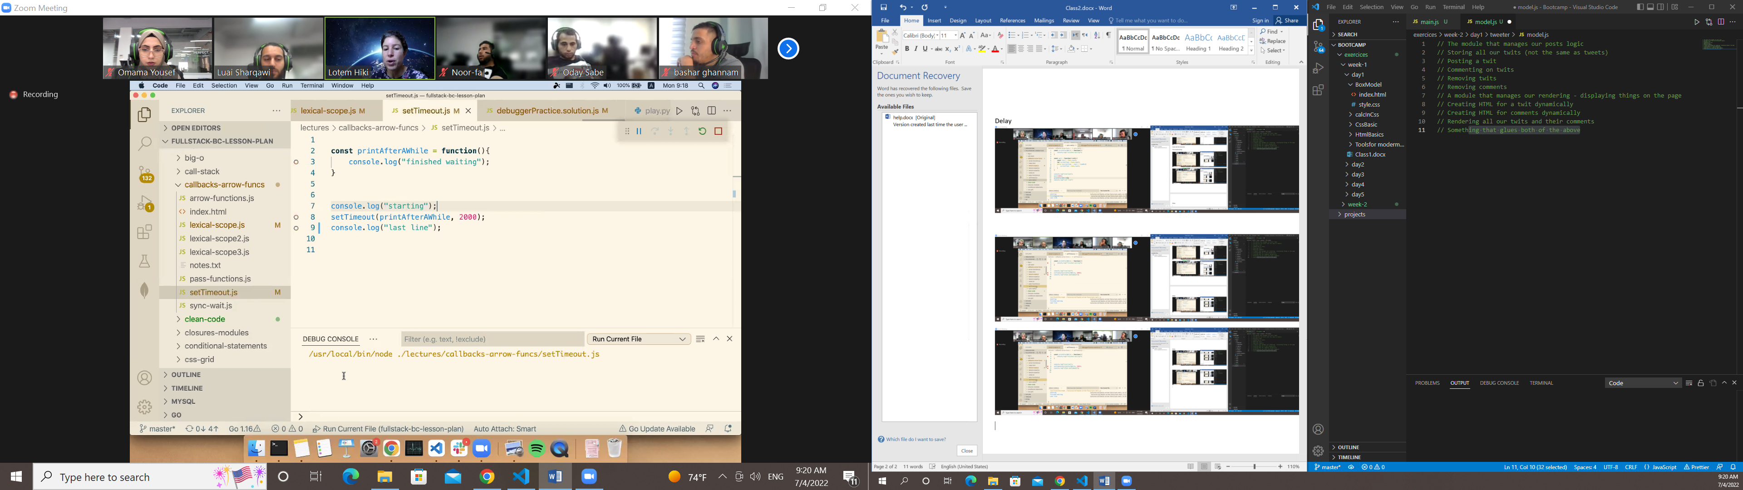

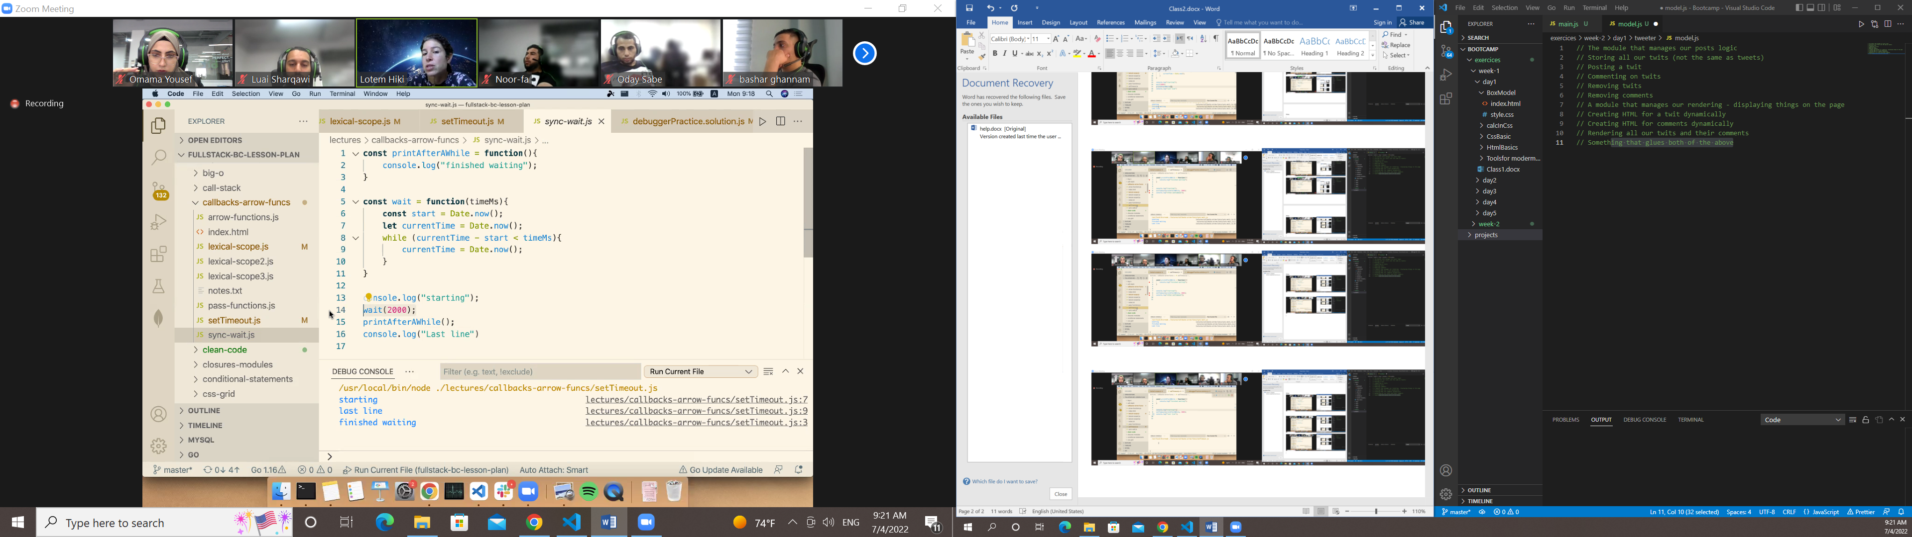

Synchronous code

Settime out is a aaaa synchronous

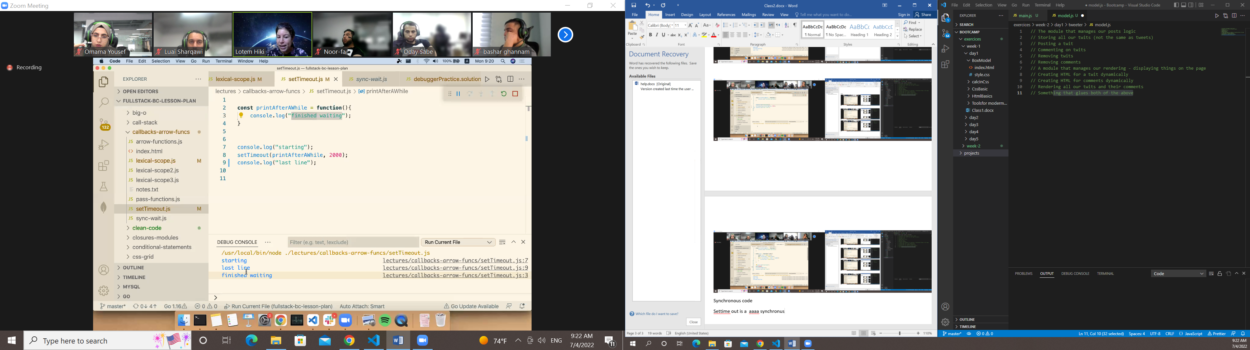

Callback in asynchri=onuse function

Where else we learned asynchronous and recive a call back?

Addevent listener not asyncrounus

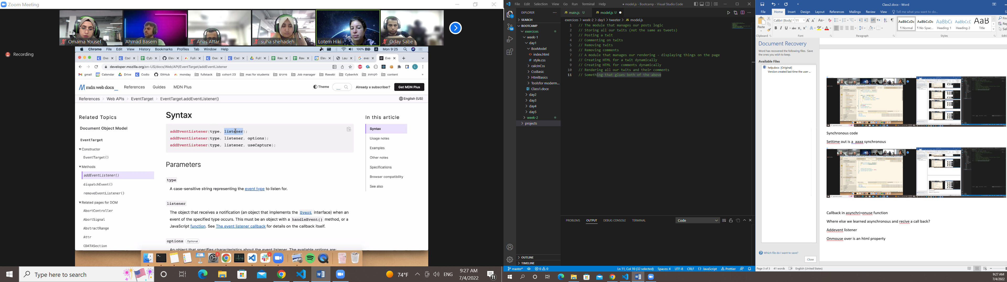

Onmouse over is an html property

ايمت بنحكي انو ااااا سنكرونيس

Its waiat until I click or sth

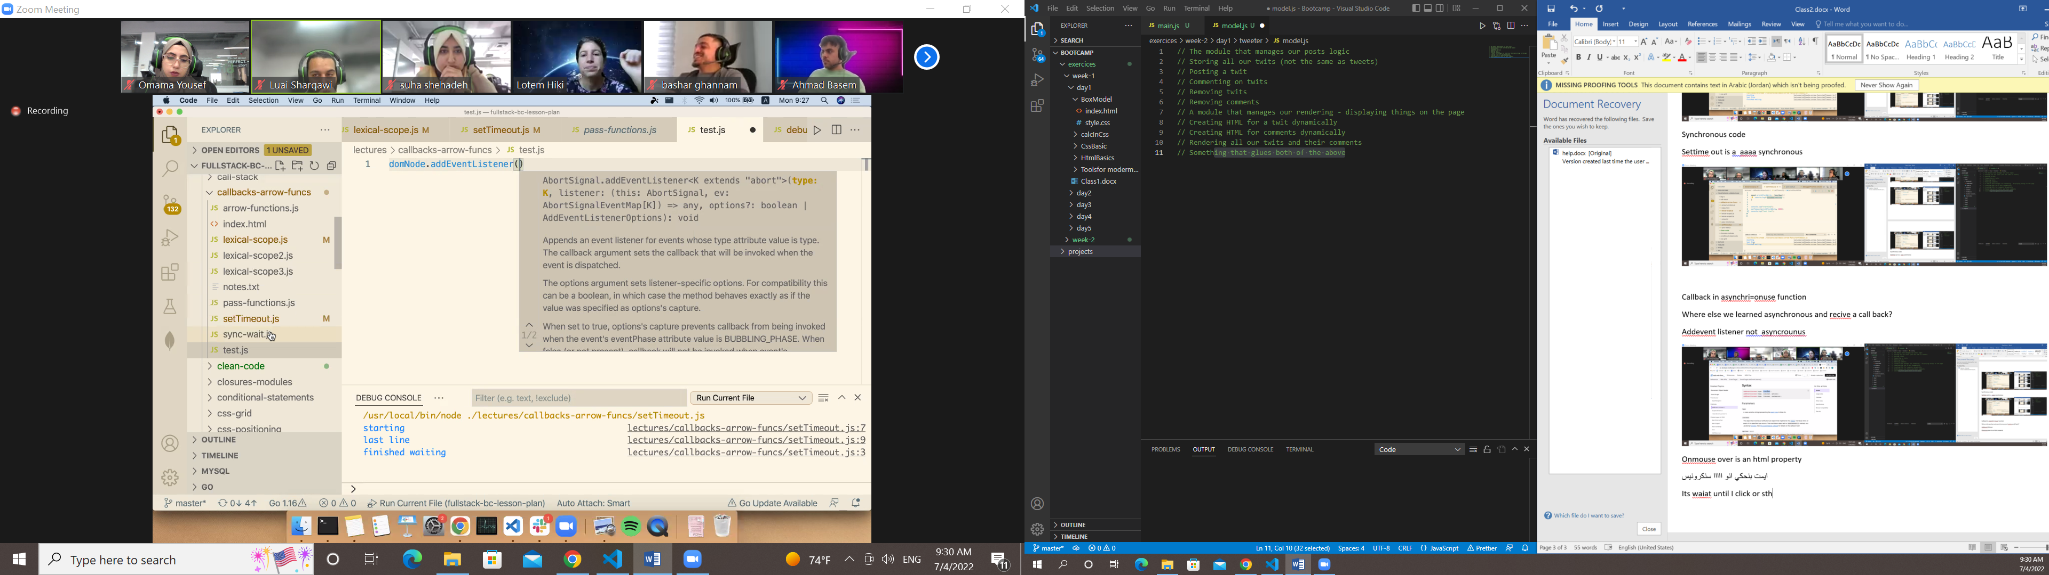

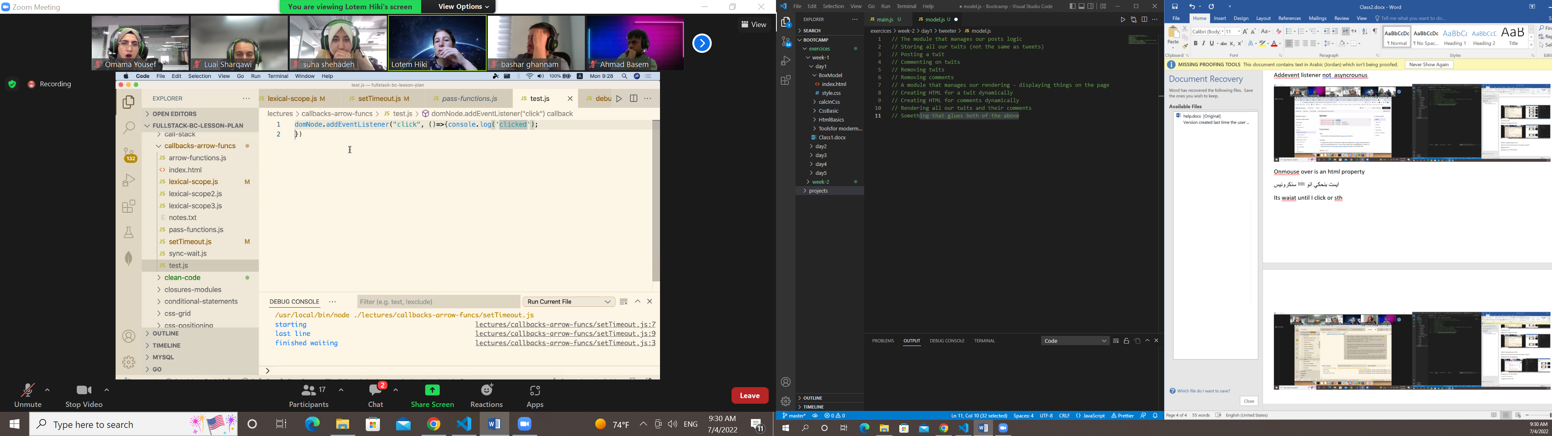

Doesn’t happened immedietly untilsth happened

ايمتا بنحتاج هيك فنكشن

Why we doesn’t not that

ايش الفايدة من asynchronous

فاثغ شممخص ةث فخ ؤخىفهىعث فاث ؤخيث عىفهم سفا اشححثى

Allow as to be dynamic

لي اسنكونس ما بنحب نحطلو callback function

The reson 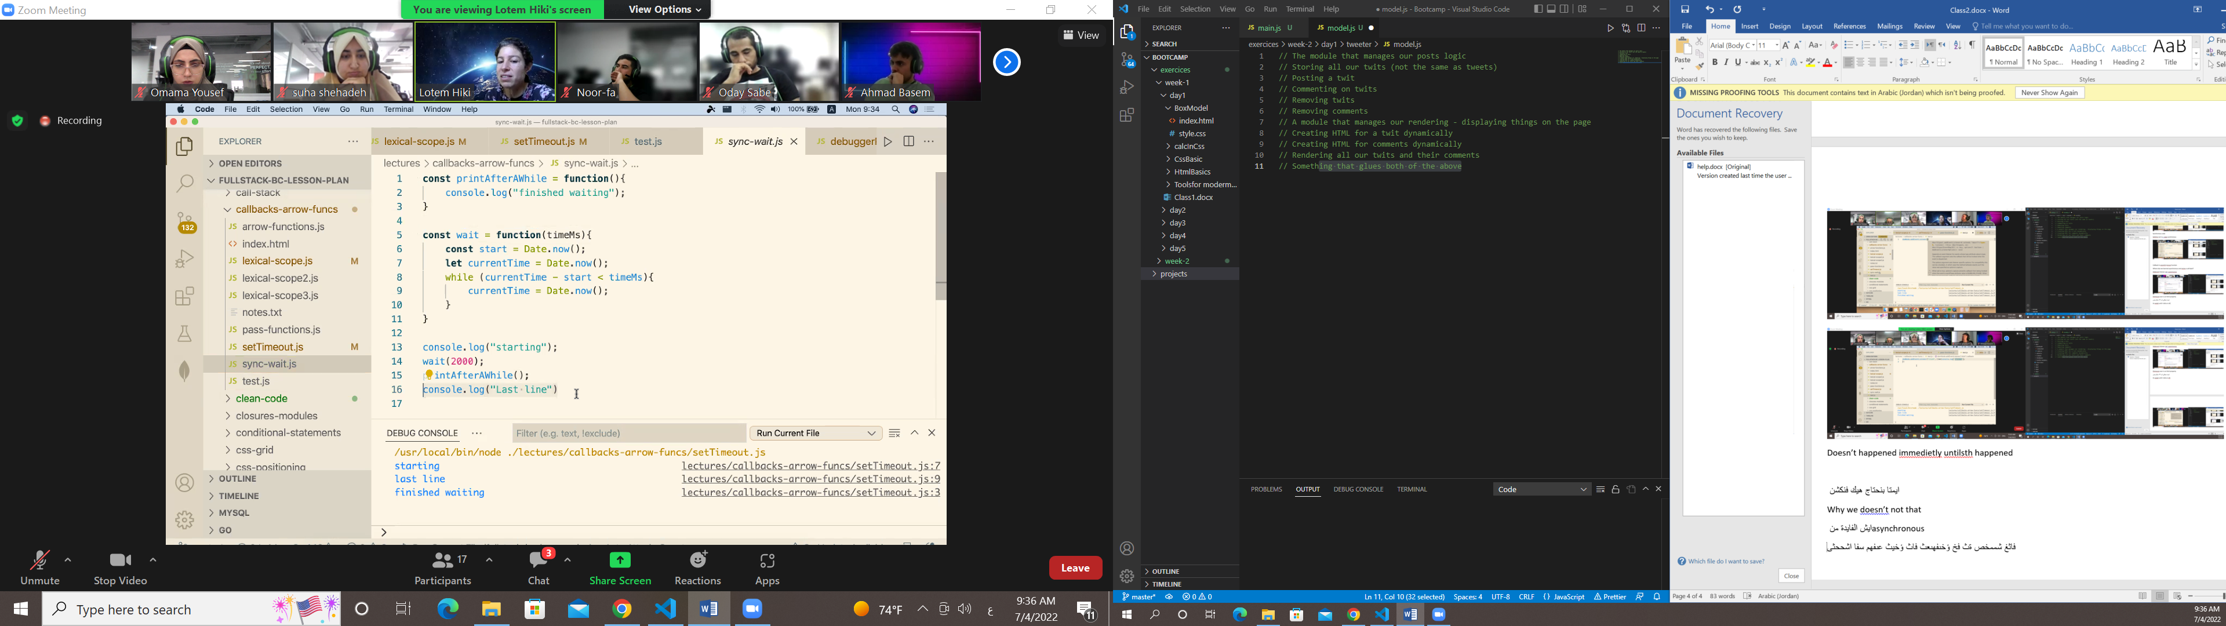

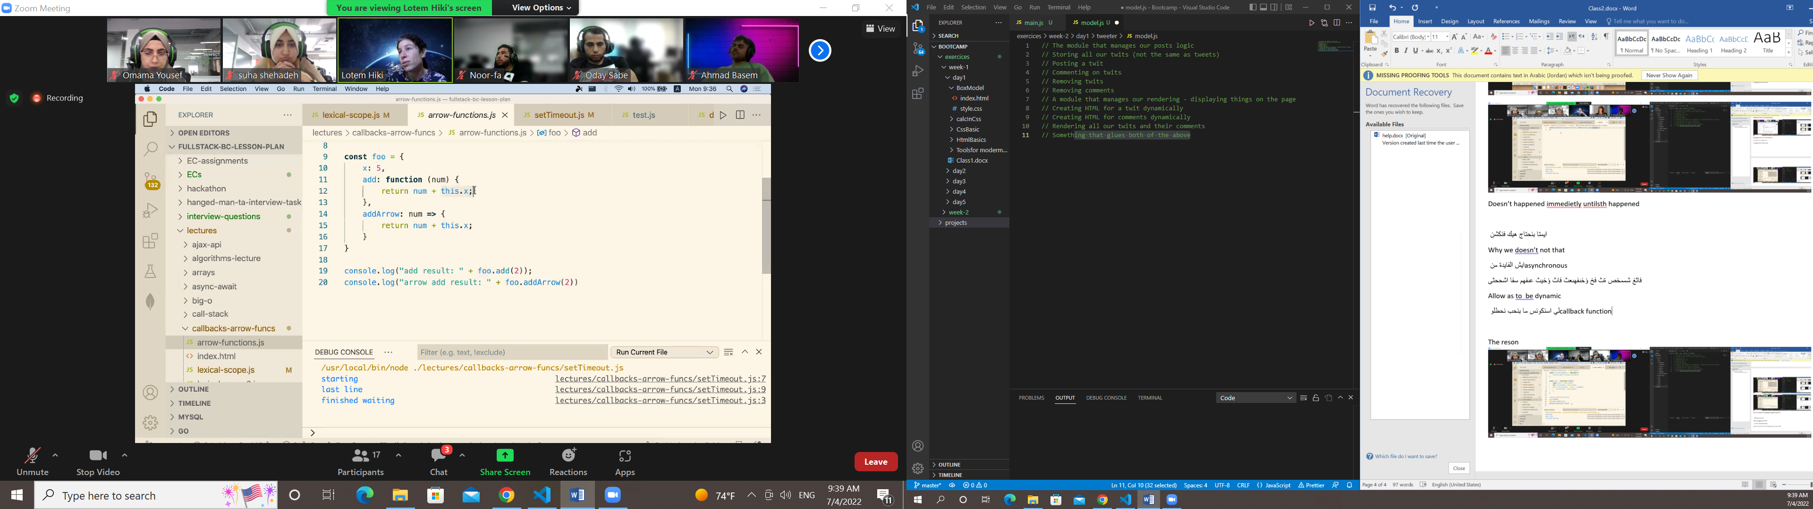

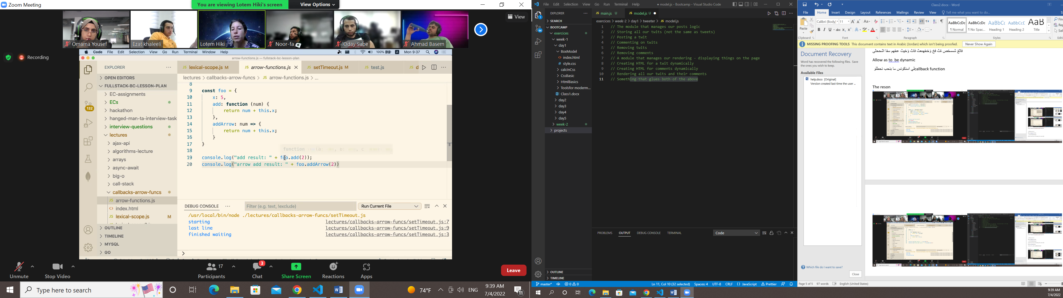

مع الارو ما بنستخدم this

This =object that call the function

In arrow بتعامل ك ليكسيكال سكوب

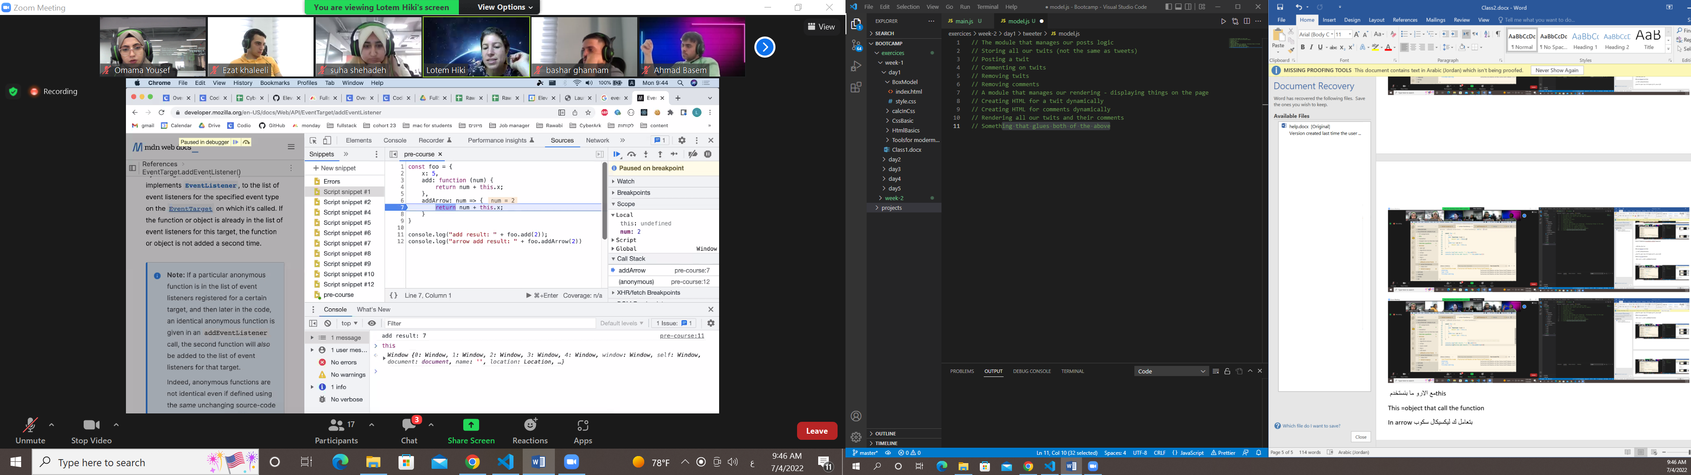

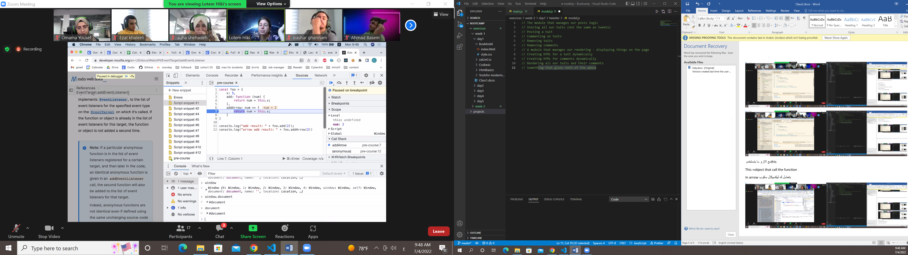

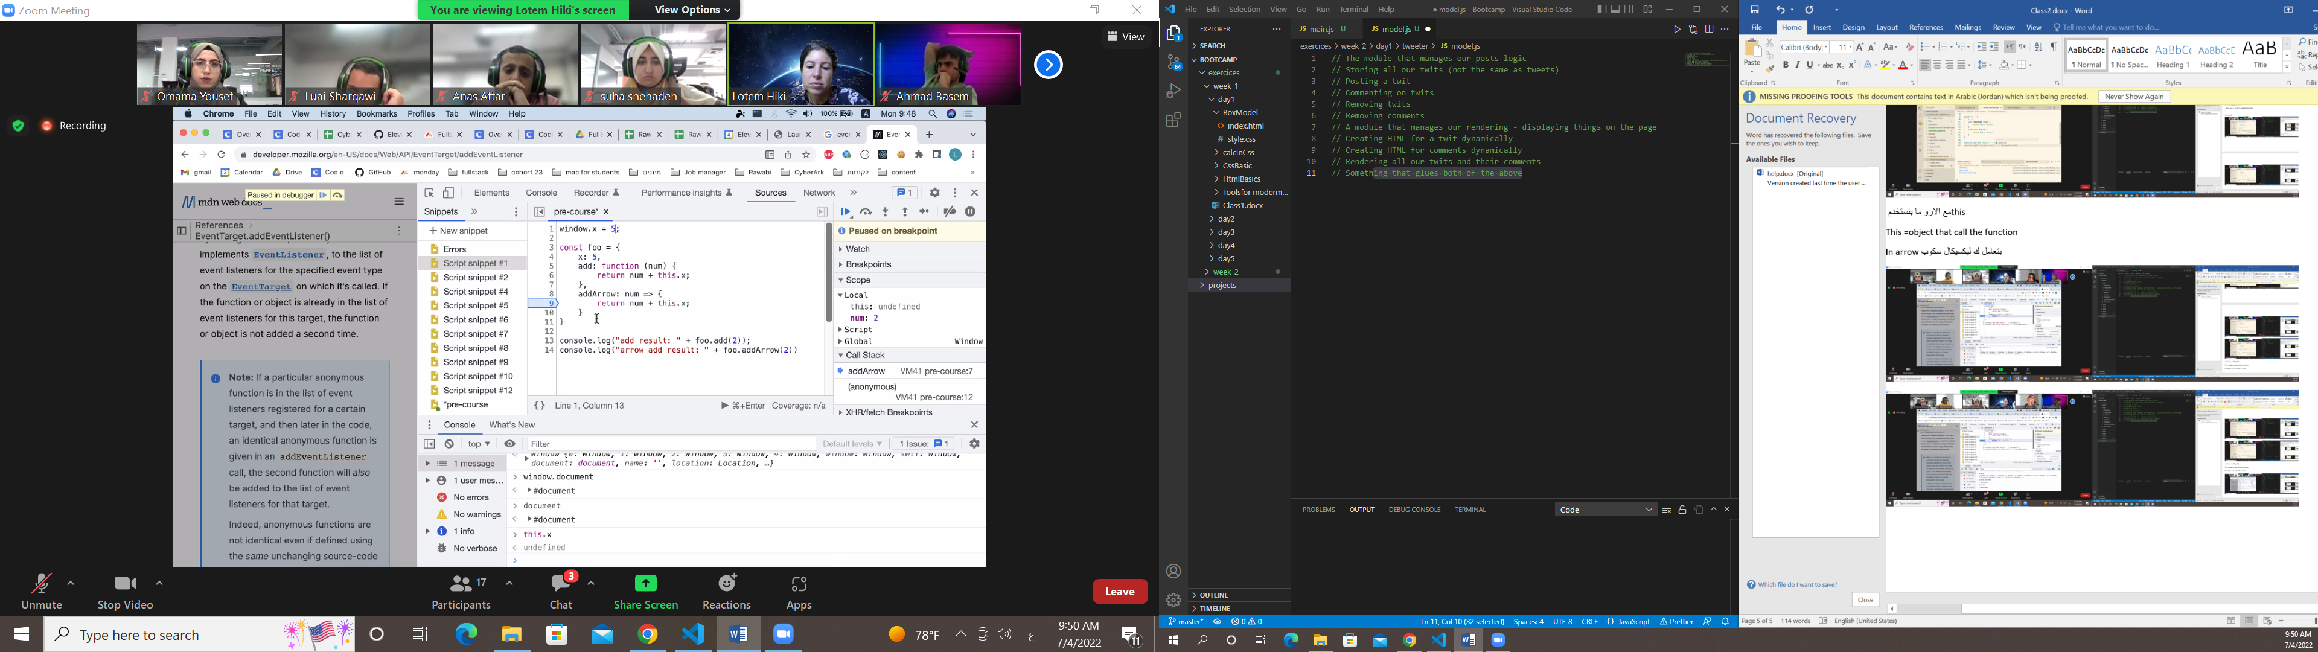

لازم اني احط x في ويندو

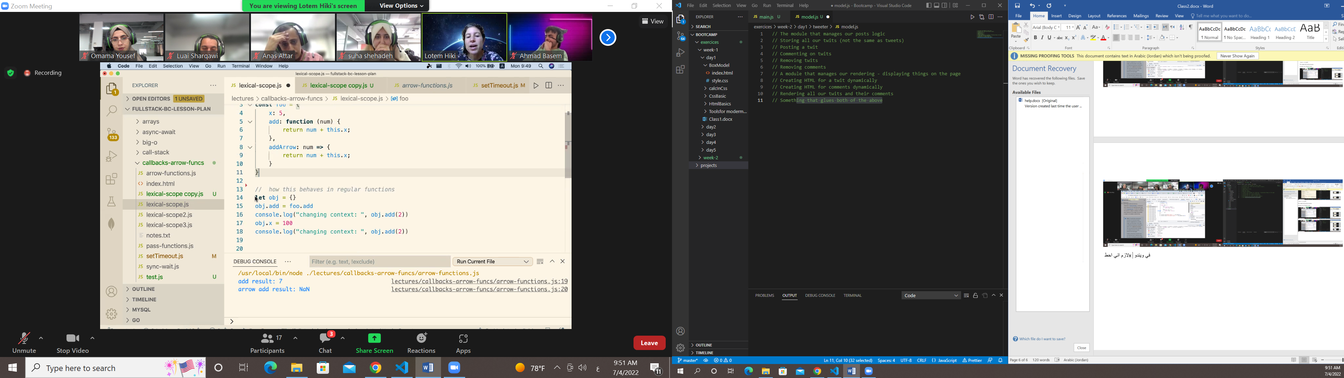

اول شي بحدد هل هو ارو ولا ريجيولر بعدها بشوف الكونتكست

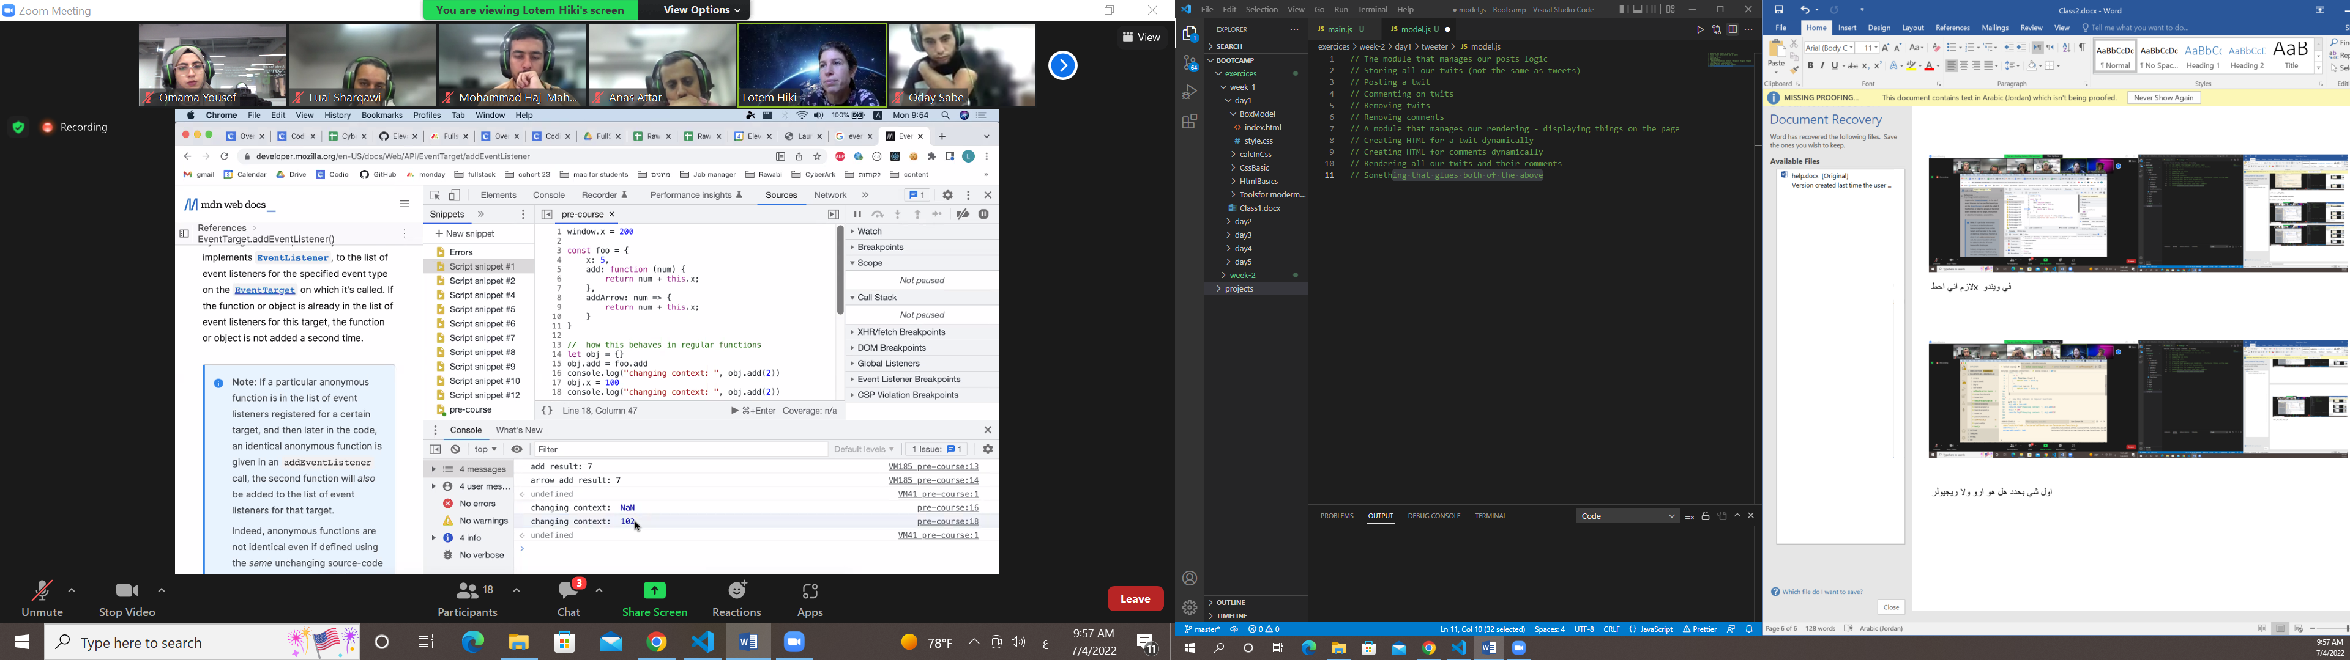

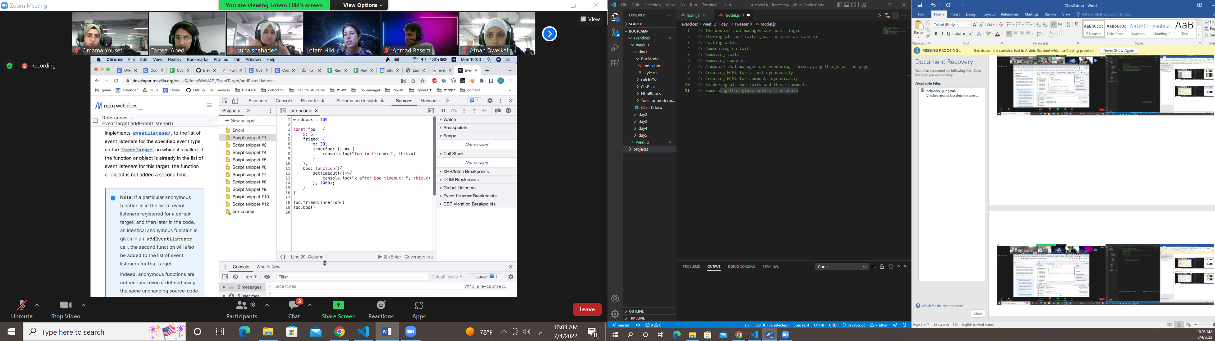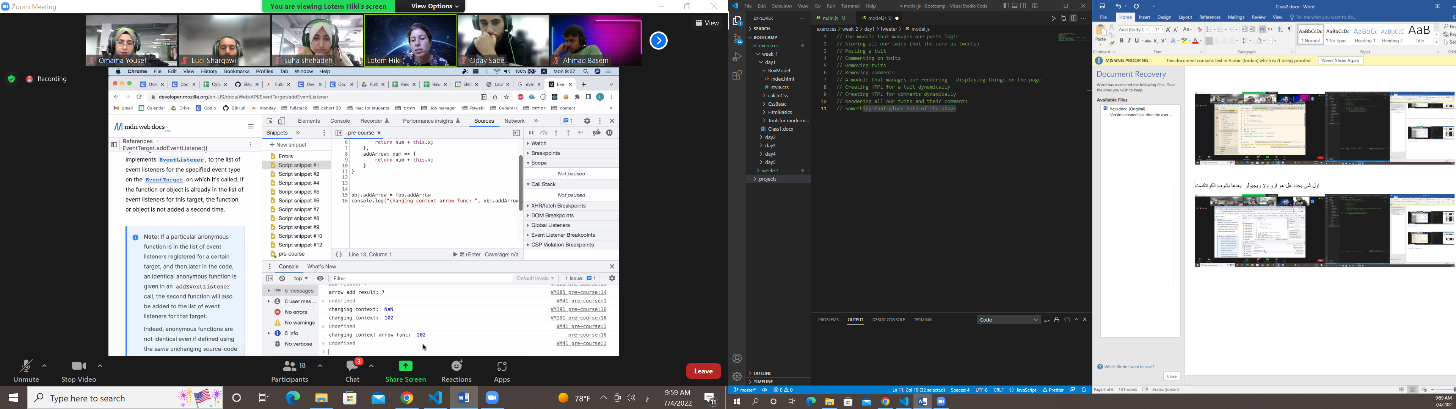

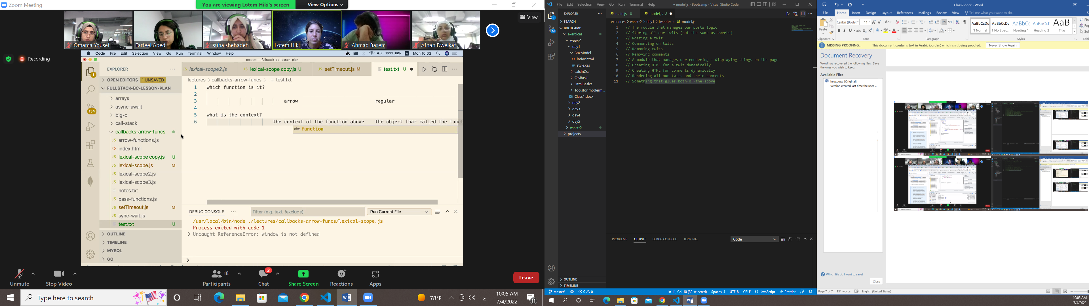

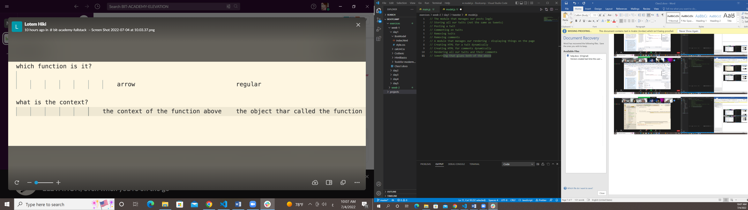

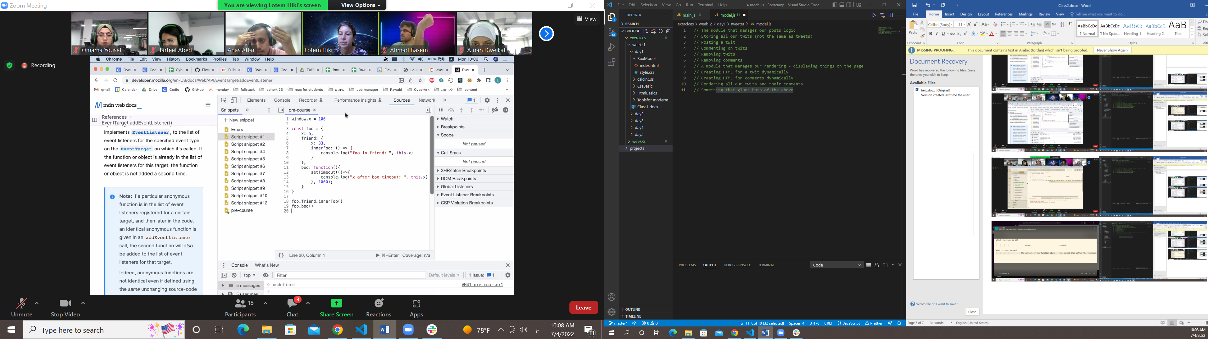

When we work with function regular contex is the object that call

Arrow function mean above

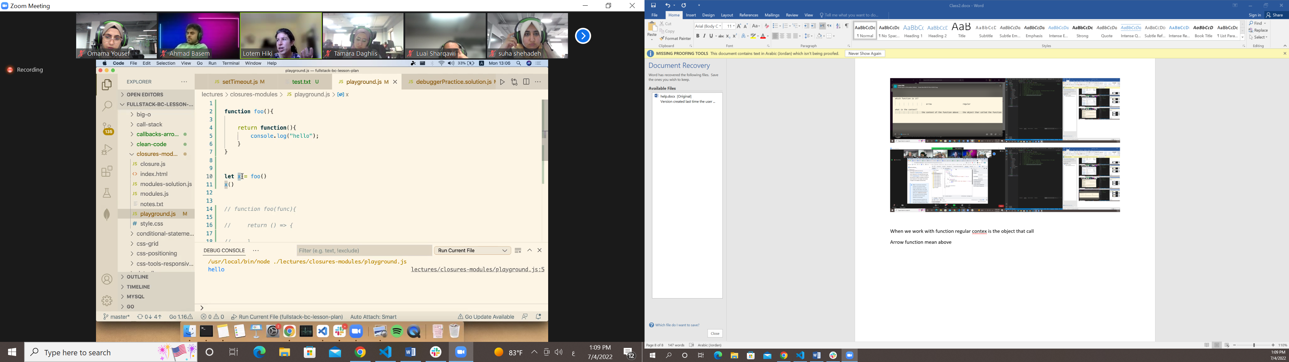

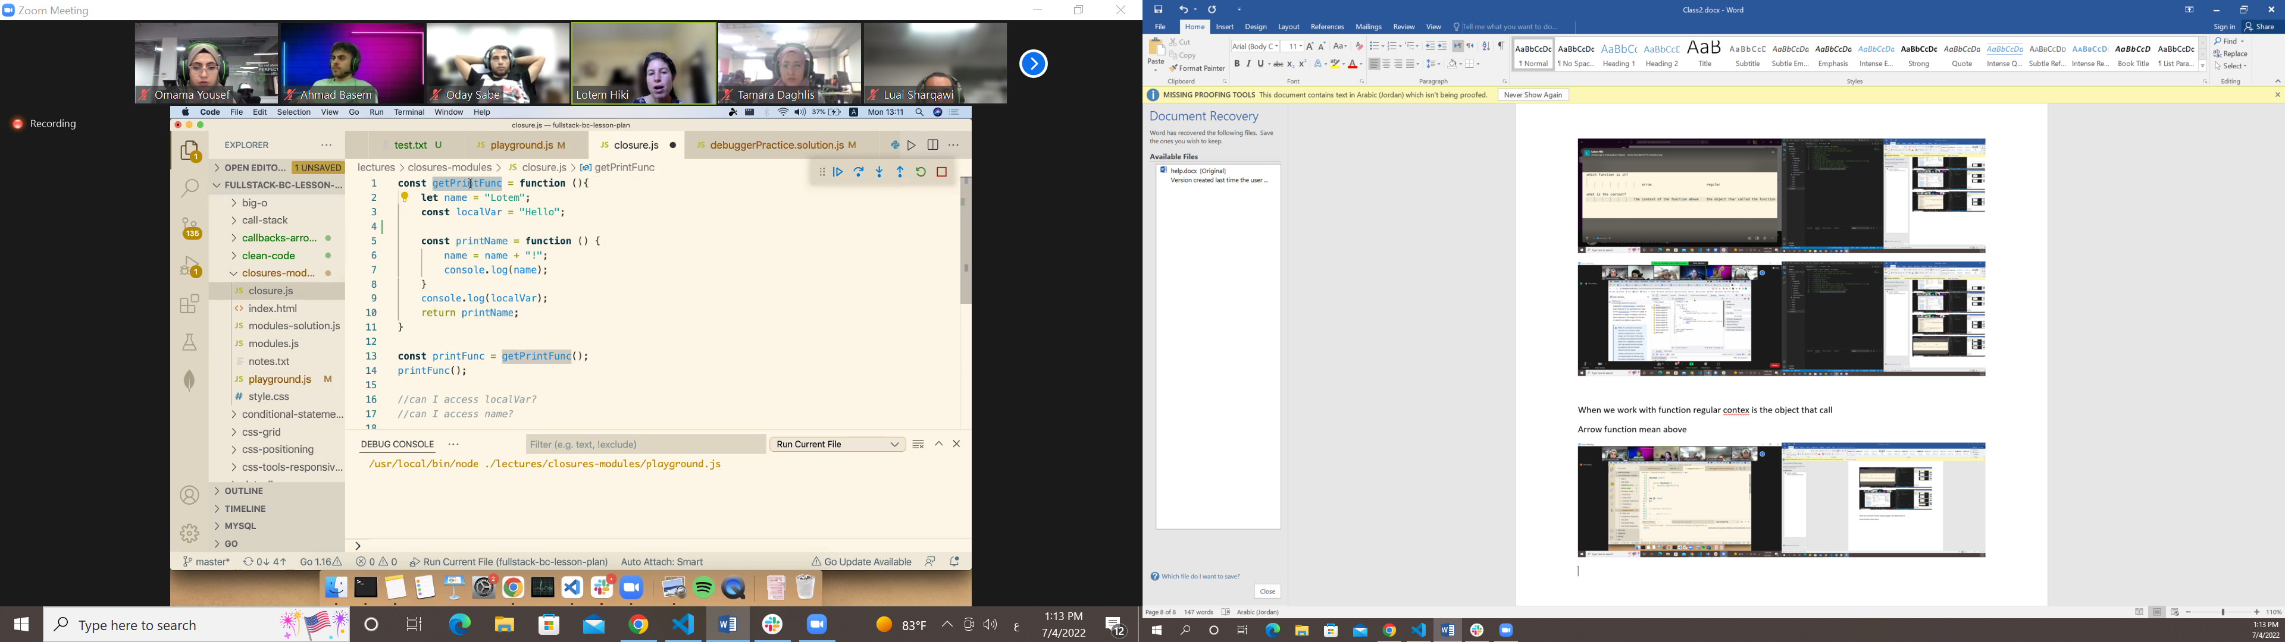

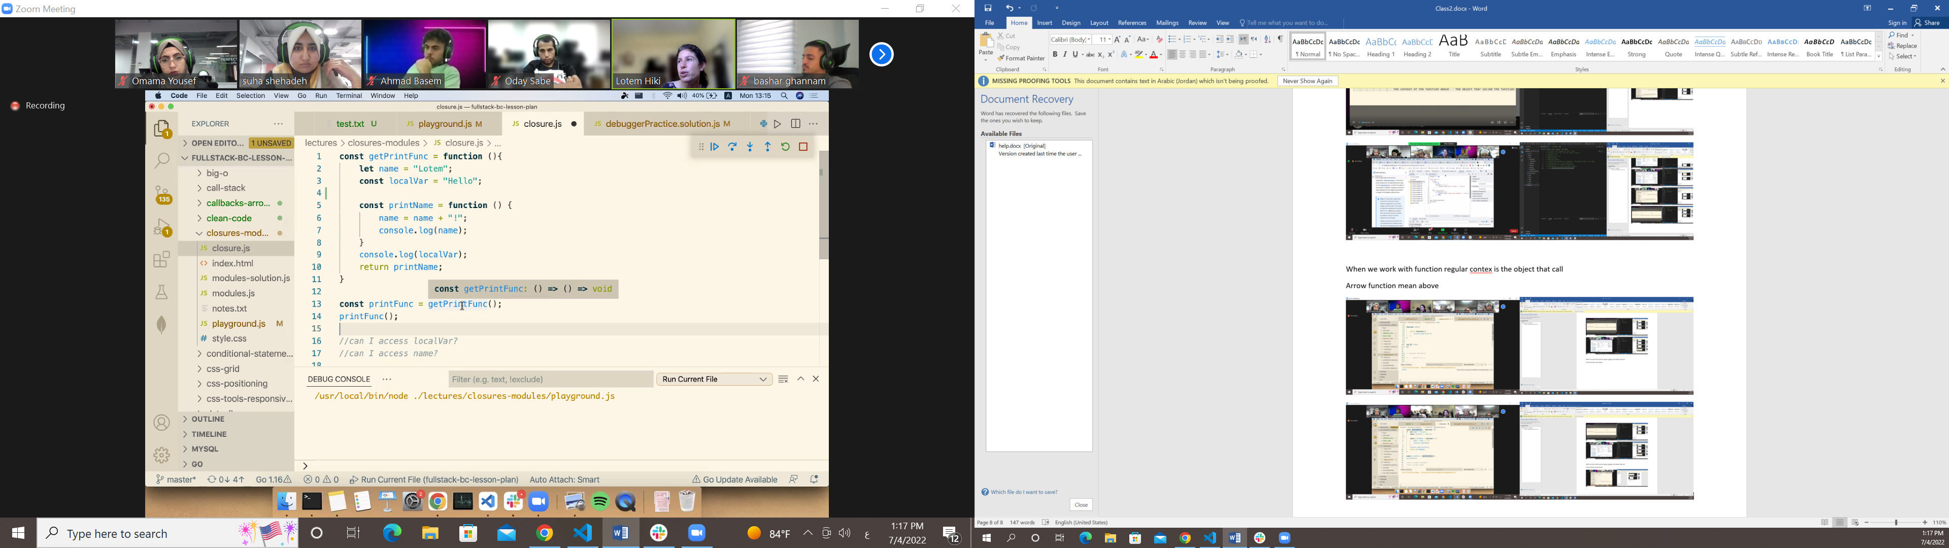

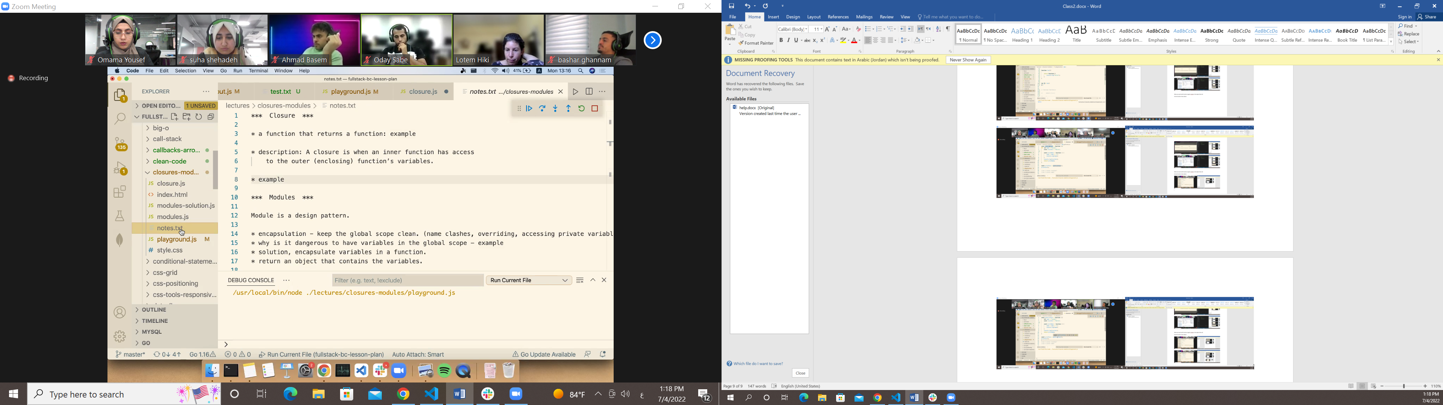

Module is a function use local scope and use clusuer to acces

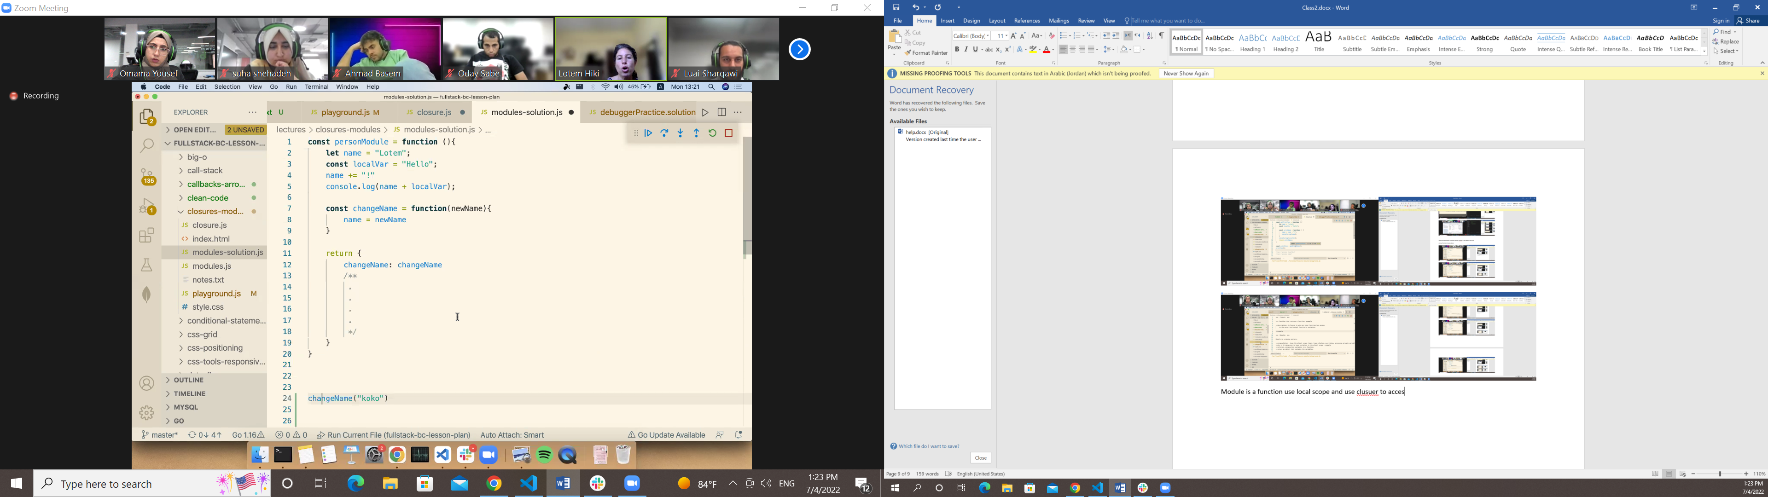

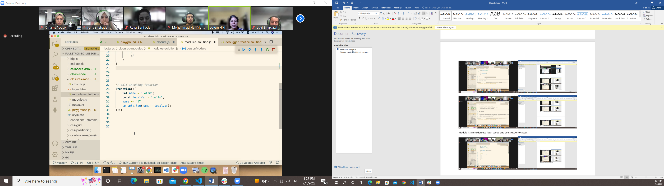

Self invoke Function that I design to store loacal data in it

Module without cluser ??? prework

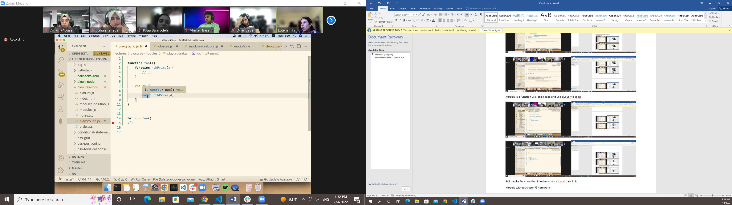

Code wriveiw

Js basic

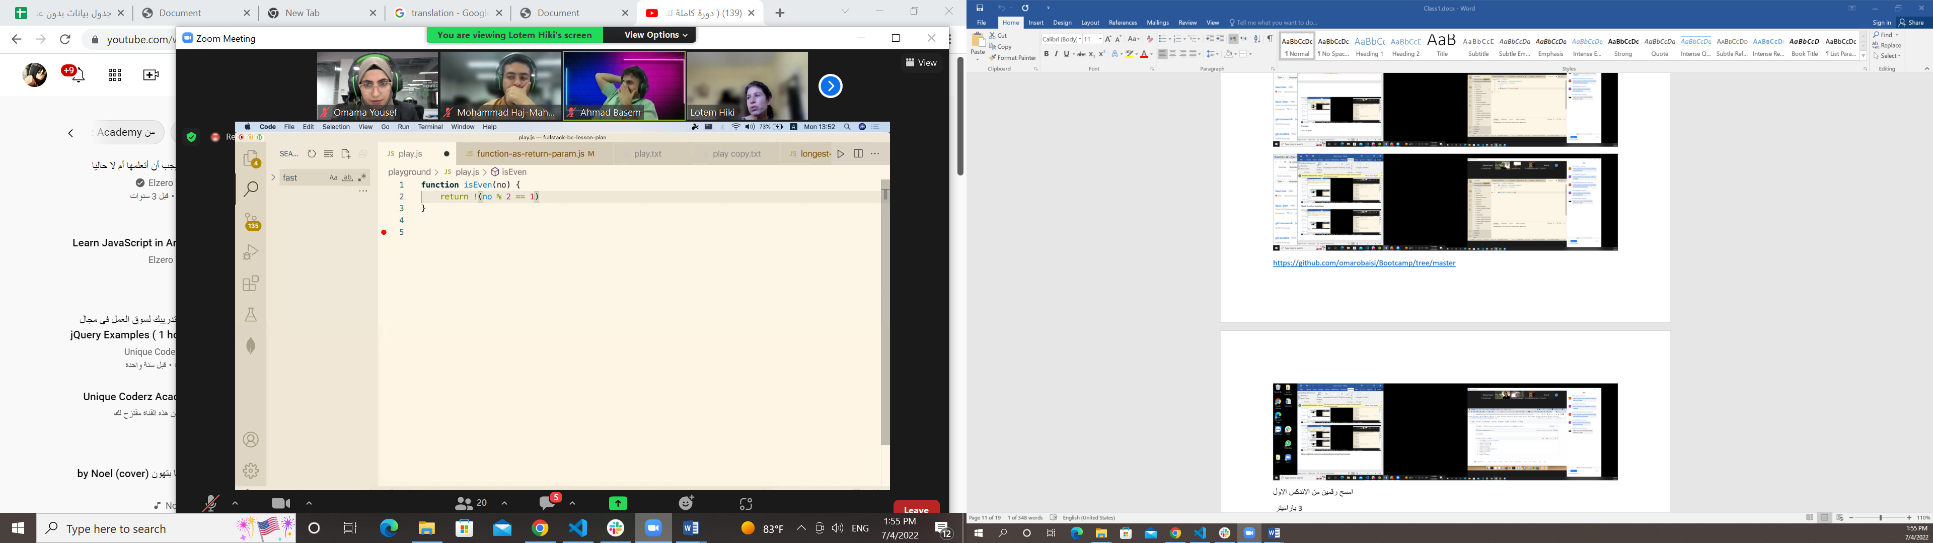

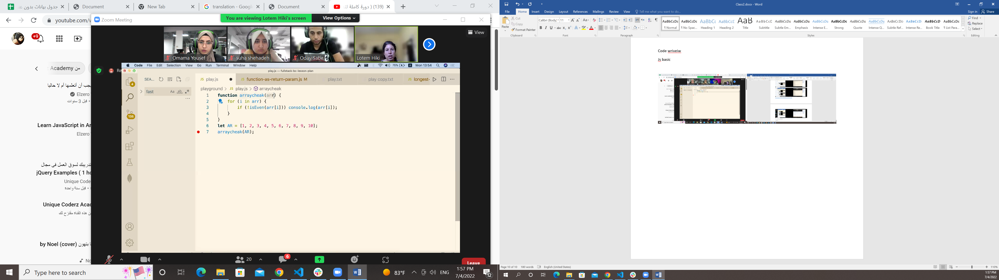

What is the array

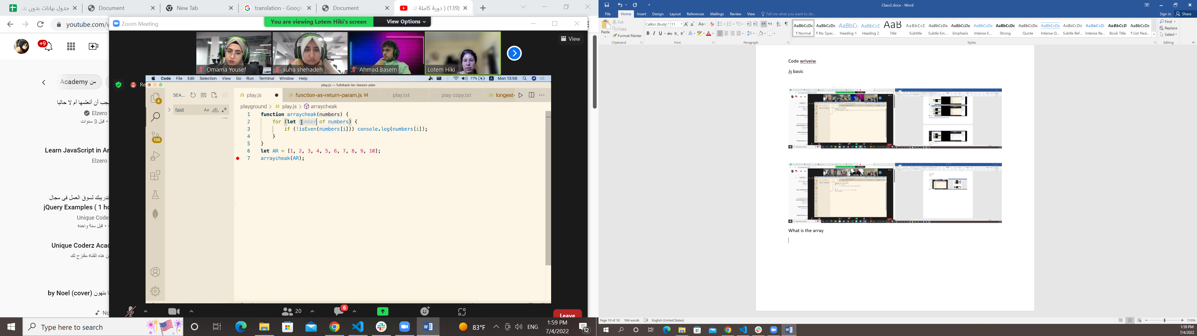

Clean code

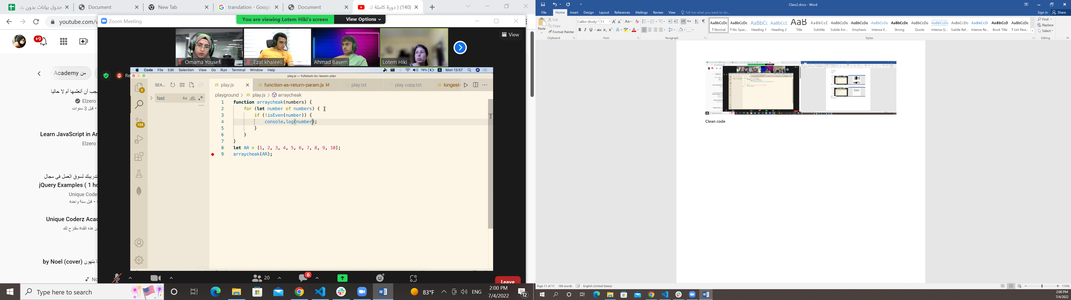

“Any fool can write code that a computer can understand. Good programmers write code that humans can understand”

Module inside module

What is self envoke function